Android ItemClickListener for a ListView with Images and Text

*October 1, 2012*

By [George Mathew](http://wptrafficanalyzer.in/blog/author/george/" \o "Posts by George Mathew)

In this article we will create an Android application with a listview which holds both text and images as listview items. On clicking an item in the listview, corresponding country name will be displayed in a Toast Message.

This article is an extension to the article “[ListView with Images and Text using Simple Adapter in Android](http://wptrafficanalyzer.in/blog/listview-with-images-and-text-using-simple-adapter-in-android" \o "ListView with Images and Text using Simple Adapter in Android)”

This application is developed in Eclipse ( 4.2.0 ) with ADT plugin ( 20.0.3 ) and Android SDK ( R20.0.3 )

**1. Create an Android application project namely “ListViewWithImagesAndTextClick”**

[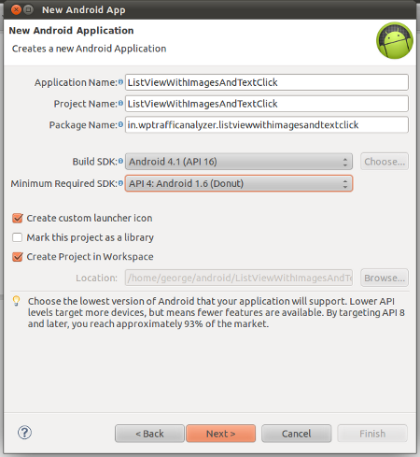](http://wptrafficanalyzer.in/blog/wp-content/uploads/2012/10/listview_with_images_text_click_new_android_project.png)

Figure 1 : Create a new Android Application Project

**2. Design Application Launcher Icon**

[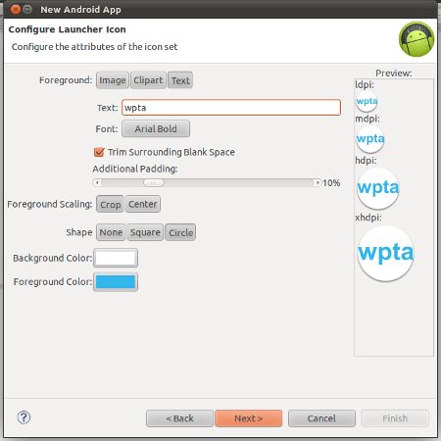](http://wptrafficanalyzer.in/blog/wp-content/uploads/2012/10/listview_with_image_text_click_design_icon.png)

Figure 2 : Design Application Launcher Icon

**3. Create a blank Activity to define the clas MainActivity**

[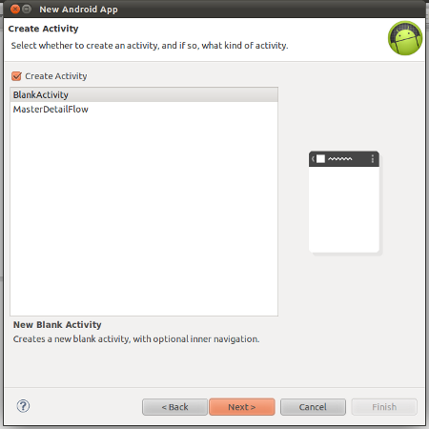](http://wptrafficanalyzer.in/blog/wp-content/uploads/2012/10/listview_with_images_text_click_blank_activity.png)

Figure 3 : Create a blank Activity

**4. Enter MainActivity details**

[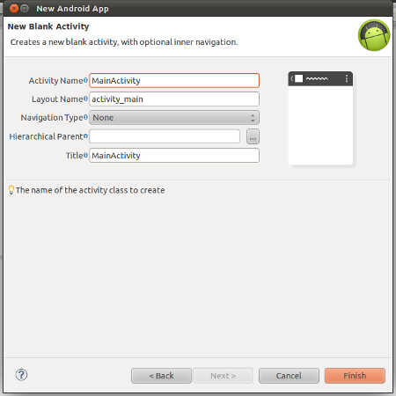](http://wptrafficanalyzer.in/blog/wp-content/uploads/2012/10/listview_with_images_text_click_main_activity.png)

Figure 4 : Enter MainActivity Details

**5. Delete Android’s Support Library from this project, if exists**

By default Eclipse ( 4.2.0) adds Android Support Library to  Android application project. For this application, we don’t need to use this support library. So the library file libs/android-support-v4.jar may be removed manually via ProjectExplorer by simply right click on the file and then clicking the menu item “delete”.

**6.Create a directory namely “drawable” in the folder res/drawable**

**7. Download and extract the**[**zip file**](http://wptrafficanalyzer.in/blog/wp-content/uploads/2012/06/flag_images.zip)**containing flag’s images to the directory /res/drawable**

**8.Open and Update the file res/values/strings.xml with the given below code**

|  |  |
| --- | --- |
| 1  2  3  4  5  6  7 | <?xml version="1.0" encoding="utf-8"?>  <resources>      <string name="hello">Hello World, MainActivity!</string>      <string name="menu_settings">Settings</string>      <string name="app_name">ListViewWithImagesAndTextItemClick</string>      <string name="title_activity_main">ListViewWithImagesAndTextItemClick</string>  </resources> |

**9.Open and update the file /res/layout/main.xml with the given below code**

|  |  |
| --- | --- |
| 1  2  3  4  5  6  7  8  9  10  11  12  13  14  15  16  17 | <?xml version="1.0" encoding="utf-8"?>  <LinearLayout xmlns:android="<http://schemas.android.com/apk/res/android>"      android:layout_width="fill_parent"      android:layout_height="fill_parent"      android:orientation="vertical" >        <TextView          android:id="@+id/textview"          android:layout_width="fill_parent"          android:layout_height="wrap_content" />        <ListView          android:id="@+id/listview"          android:layout_width="fill_parent"          android:layout_height="wrap_content" />    </LinearLayout> |

**10. Create a new file namely /res/layout/listview_layout.xml  and update the content with the given below code**

|  |  |
| --- | --- |
| 1  2  3  4  5  6  7  8  9  10  11  12  13  14  15  16  17  18  19  20  21  22  23  24  25  26  27  28  29  30  31  32  33 | <?xml version="1.0" encoding="utf-8"?>  <LinearLayout xmlns:android="<http://schemas.android.com/apk/res/android>"      android:layout_width="match_parent"      android:layout_height="match_parent"      android:orientation="horizontal" >        <ImageView          android:id="@+id/flag"          android:layout_width="wrap_content"          android:layout_height="wrap_content"          android:contentDescription="@string/hello"          android:paddingTop="10dp"          android:paddingRight="10dp"          android:paddingBottom="10dp" />        <LinearLayout          android:layout_width="match_parent"          android:layout_height="match_parent"          android:orientation="vertical" >        <TextView          android:id="@+id/txt"          android:layout_width="wrap_content"          android:layout_height="wrap_content"          android:textSize="15dp" />        <TextView          android:id="@+id/cur"          android:layout_width="wrap_content"          android:layout_height="wrap_content"          android:textSize="10dp" />      </LinearLayout>  </LinearLayout> |

**11. Open and update the file /src/in/wptrafficanalyzer/listviewwithimagesandtextclick/MainActivity.java with the given below code**

|  |  |
| --- | --- |
| 1  2  3  4  5  6  7  8  9  10  11  12  13  14  15  16  17  18  19  20  21  22  23  24  25  26  27  28  29  30  31  32  33  34  35  36  37  38  39  40  41  42  43  44  45  46  47  48  49  50  51  52  53  54  55  56  57  58  59  60  61  62  63  64  65  66  67  68  69  70  71  72  73  74  75  76  77  78  79  80  81  82  83  84  85  86  87  88  89  90  91  92  93  94  95  96  97  98  99  100  101  102  103  104  105  106  107  108  109  110  111  112  113  114  115  116  117  118  119  120  121  122 | package in.wptrafficanalyzer.listviewwithimagesandtextclick;    import java.util.ArrayList;  import java.util.HashMap;  import java.util.List;    import android.app.Activity;  import android.os.Bundle;  import android.view.Menu;  import android.view.View;  import android.widget.AdapterView;  import android.widget.AdapterView.OnItemClickListener;  import android.widget.LinearLayout;  import android.widget.ListView;  import android.widget.SimpleAdapter;  import android.widget.TextView;  import android.widget.Toast;    public class MainActivity extends Activity {        // Array of strings storing country names      String[] countries = new String[] {          "India",          "Pakistan",          "Sri Lanka",          "China",          "Bangladesh",          "Nepal",          "Afghanistan",          "North Korea",          "South Korea",          "Japan"      };        // Array of integers points to images stored in /res/drawable-ldpi/      int[] flags = new int[]{          R.drawable.india,          R.drawable.pakistan,          R.drawable.srilanka,          R.drawable.china,          R.drawable.bangladesh,          R.drawable.nepal,          R.drawable.afghanistan,          R.drawable.nkorea,          R.drawable.skorea,          R.drawable.japan      };        // Array of strings to store currencies      String[] currency = new String[]{          "Indian Rupee",          "Pakistani Rupee",          "Sri Lankan Rupee",          "Renminbi",          "Bangladeshi Taka",          "Nepalese Rupee",          "Afghani",          "North Korean Won",          "South Korean Won",          "Japanese Yen"      };        /** Called when the activity is first created. */      @Override      public void onCreate(Bundle savedInstanceState) {          super.onCreate(savedInstanceState);          setContentView(R.layout.main);            // Each row in the list stores country name, currency and flag          List<HashMap<String,String>> aList = new ArrayList<HashMap<String,String>>();            for(int i=0;i<10;i++){              HashMap<String, String> hm = new HashMap<String,String>();              hm.put("txt", "Country : " + countries[i]);              hm.put("cur","Currency : " + currency[i]);              hm.put("flag", Integer.toString(flags[i]) );              aList.add(hm);          }            // Keys used in Hashmap          String[] from = { "flag","txt","cur" };            // Ids of views in listview_layout          int[] to = { R.id.flag,R.id.txt,R.id.cur};            // Instantiating an adapter to store each items          // R.layout.listview_layout defines the layout of each item          SimpleAdapter adapter = new SimpleAdapter(getBaseContext(), aList, R.layout.listview_layout, from, to);            // Getting a reference to listview of main.xml layout file          ListView listView = ( ListView ) findViewById(R.id.listview);            // Setting the adapter to the listView          listView.setAdapter(adapter);            // Item Click Listener for the listview          OnItemClickListener itemClickListener = new OnItemClickListener() {              @Override              public void onItemClick(AdapterView<?> parent, View container, int position, long id) {                  // Getting the Container Layout of the ListView                  LinearLayout linearLayoutParent = (LinearLayout) container;                    // Getting the inner Linear Layout                  LinearLayout linearLayoutChild = (LinearLayout ) linearLayoutParent.getChildAt(1);                    // Getting the Country TextView                  TextView tvCountry = (TextView) linearLayoutChild.getChildAt(0);                    Toast.makeText(getBaseContext(), tvCountry.getText().toString(), Toast.LENGTH_SHORT).show();              }          };            // Setting the item click listener for the listview          listView.setOnItemClickListener(itemClickListener);      }        @Override      public boolean onCreateOptionsMenu(Menu menu) {          getMenuInflater().inflate(R.menu.activity_main, menu);          return true;      }  } |

**12. Open and Update the file res/values/styles.xml**

|  |  |
| --- | --- |
| 1  2  3 | <resources>      <style name="AppTheme" parent="android:Theme" />  </resources> |

**13. Open and Update the file res/values-v11/styles.xml**

|  |  |
| --- | --- |
| 1  2  3 | <resources>      <style name="AppTheme" parent="android:Theme.Holo" />  </resources> |

**14. Open and Update the file res/values-v14/styles.xml**

|  |  |
| --- | --- |
| 1  2  3 | <resources>      <style name="AppTheme" parent="android:Theme.Holo" />  </resources> |

**15. Run the application**

[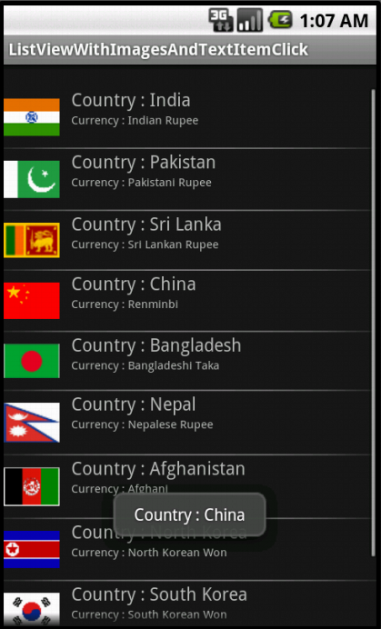](http://wptrafficanalyzer.in/blog/wp-content/uploads/2012/10/listview_with_images_and_text_clicik.png)

Figure 5 : Screenshot of the application in Action

**16. Download the source code**

http://wptrafficanalyzer.in/blog/wp-content/plugins/download-manager/file-type-icons/zip.png

**Android ItemClickListener for a ListView with Images and Text**173.33 KB

**[Download Full Source Code](http://wptrafficanalyzer.in/blog/?wpdmdl=9265)**